Apache Spark training

Table of Contents

Installation 2

Pre-Req: 2

Release Notes: 2

Guide: 3

Steps: 3

Start and Stop 5

Components: 6

List of All Components: 6

Status of All Components: 6

VM Access 7

Using Browser: 7

Using Terminal: 7

Sandbox 7

Components: 8

HDFS: 8

Overview: 8

Check 8

Hive: 8

Overview: 9

Details: 9

Commands: 9

Config Properties 9

Kafka 9

Overview: 9

Topic: 9

Partition: 9

Retention Period: 10

Topic and Partition: 10

Offset Positions Per Consumer: 11

Kafka Cluster: Multi-Node Kafka Servers. 11

Kafka Services in HDP: 12

Check: 12

Create Kafka Topic: 13

Produce Data into Topic: 14

Consume Data from Topic: 14

Topic Offsets: 14

Consume Group Offsets: 14

Spark 16

Overview: 16

Stack: 16

Concepts: 17

Cluster Mode: 18

YARN: 19

Driver: 19

Executors: 19

Sources: 19

Sink: 19

Streaming: 20

Spark + Kafka 21

Kerberos: 23

Broadcast: 24

HBase: 24

Features: 25

Hive: 26

Data Formats: 26

AVRO 26

ORC: 26

PARQUET: 26

Scala Program: 26

Build and Deploy: 26

Project: 27

IDE: 27

Project: 27

Build: 28

Compile & Package: 28

Payload: 28

Upload: 28

Run Program: 29

Sandbox: 29

GCP: 29

Applications 30

Produce Data to Kafka 30

Consume Data from Kafka 30

Kafka Streams Application 30

Spark Application: 30

Read from Kafka: 30

Apply Transformation 30

Write to HDFS 30

Write to HIVE 30

Write to HBase 30

Troubleshoot: 31

Interview Preparation: 31

# Installation

## Pre-Req:

Make sure your computer is having minimum 16GB RAM and Quad Core CPU. HDP platform would need 10+GB to start the sandbox.

## Release Notes:

<https://www.cloudera.com/tutorials/hortonworks-sandbox-guide/1.html>

## Guide:

https://www.cloudera.com/tutorials/getting-started-with-hdp-sandbox.html

## Steps:

* Download Sandbox:
  + https://www.cloudera.com/downloads/hortonworks-sandbox.html
* Download Virtual Box:
  + <https://www.virtualbox.org/wiki/Downloads>
* Install Virtual Box
* Start Virtual Box
* Virtual Box: Import OVA File download for Sandbox
* Virtual Box: Settings -> Network -> Bridge

* Virtual Box: Start Server (will take some time, only first time)

* Verify:

## Start and Stop

* Start your virtual box
* Start the Imported Sandbox VM
* Wait for it to start the VM and print the welcome page

* Take a note of the IP address.
* Open Browser and access the web page with given IP and Port.
  + Example: <http://192.168.5.137:1080/>
* Access Quick Links
  + <http://192.168.5.137:1080/splash2.html>
* Access Ambari
  + <http://192.168.5.137:8080/#/login>, User and password is given in the same page.
  + username & password: raj_ops
* Check to make sure all the required components are installed, started and healthy.

# Components:

## List of All Components:

<https://docs.cloudera.com/HDPDocuments/HDP3/HDP-3.0.1/release-notes/content/comp_versions.html>

## Status of All Components:

<http://192.168.5.137:8080/#/main/hosts/sandbox-hdp.hortonworks.com/summary>

Important components that we need for this training:

* HDFS
* YARN
* MapReduce2
* Tez
* Hive
* Hbase (may need more resources like RAM and CPU)
* Zookeeper
* Kafka
* Spark2

# VM Access

In case you want to access terminal and use command line tools.

username & password: **root / hadoop**

Note: system will ask you to change password on first login.

### Using Browser:

<http://192.168.5.137:4200/>

## Using Terminal:

### Sandbox

>ssh [root@192.168.5.137](mailto:root@192.168.5.137) (IP address refer to virtual box->popup screen)

>>ssh [root@172.18.0.2](mailto:root@172.18.0.2)

# Components:

## HDFS:

### Overview:

Hadoop Distributed File System (HDFS), a distributed storage used by Hadoop applications.

A HDFS cluster primarily consists of a NameNode that manages the file system metadata and DataNodes that store the actual data

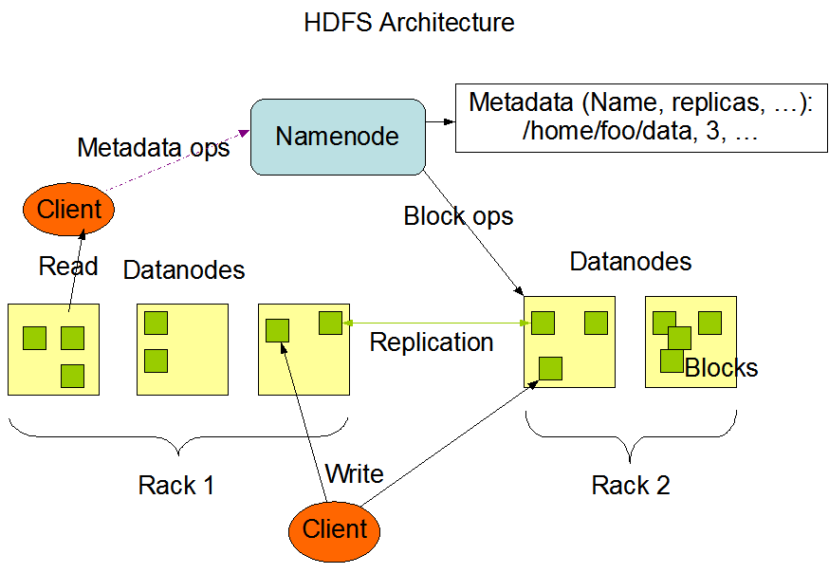

### Check

Make sure HDFS is running and healthy from Ambari.

[root@sandbox-hdp ~]# hadoop fs -ls /

## Hive:

### Overview:

A data warehouse like system with reading, writing, and managing large datasets residing in distributed storage using SQL.

### Details:

<https://cwiki.apache.org/confluence/display/Hive/Home>

### Commands:

>hive

>> show databases;

>> use foodmart;

>> show tables;

>> desc days;

>> show create table days;

### Config Properties

<http://192.168.5.137:8080/#/main/services/HIVE/configs>

## Kafka

### Overview:

A streaming platform has three key capabilities:

* Publish and subscribe to streams of records, like message queues.
* Store streams of records in a fault-tolerant durable way.
* Process streams of records as they occur

Kafka stores streams of records in categories called topics. Each record consists of a key, a value, and a timestamp.

### Topic:

A topic is a category or feed name to which records are published. Topics in Kafka are always multi-subscriber; that is, a topic can have zero, one, or many consumers that subscribe to the data written to it.

### Partition:

Each partition is an ordered, immutable sequence of records that is continually appended. Each record in the partitions are each assigned a sequential id number called the offset that uniquely identifies each record within the partition.

### Retention Period:

If the retention policy is set to two days, then for the two days after a record is published, it is available for consumption, after which it will be discarded to free up space.

### Topic and Partition:

### Offset Positions Per Consumer:

### Kafka Cluster: Multi-Node Kafka Servers.

### Kafka Services in HDP:

Wait for some time for all the services to start. Check the status here:

Started Fine:

Ambari: <http://192.168.5.137:8080/#/main/dashboard/metrics>

### Check:

* Cluster is up
* Zookeeper is up
* Bootstrap server is up
* Kafka service is up

### Create Kafka Topic:

#### Sandbox:

> /usr/hdp/3.0.1.0-187/kafka/bin/kafka-topics.sh --create --zookeeper localhost:2181 --replication-factor 1 --partitions 2 --topic tp_in_profileupdat

Es

#### GCP:

>sh /usr/hdp/3.1.4.0-315/kafka/bin/kafka-topics.sh --create --zookeeper instance-1.us-east1-b.c.wired-effort-272101.internal:2181 --replication-factor 1 --partitions 2 --topic tp_in_profileupdates

Created topic "tp_in_profileupdates".

>sh /usr/hdp/3.1.4.0-315/kafka/bin/kafka-topics.sh --create --zookeeper instance-1.us-east1-b.c.wired-effort-272101.internal:2181 --replication-factor 1 --partitions 2 --topic SourceTopic

Created topic "SourceTopic".

>sh /usr/hdp/3.1.4.0-315/kafka/bin/kafka-topics.sh --create --zookeeper instance-1.us-east1-b.c.wired-effort-272101.internal:2181 --replication-factor 1 --partitions 2 --topic SinkTopic

Created topic "SinkTopic".

Partitions: 2

Replication Factor: 1

#### List Topics:

Sandbox

>/usr/hdp/3.0.1.0-187/kafka/bin/kafka-topics.sh --list --zookeeper localhost:2181

#### Describe Topic:

Sandbox

>/usr/hdp/3.0.1.0-187/kafka/bin/kafka-topics.sh --zookeeper localhost:2181 --describe --topic tp_in_profileupdates

GCP Cluster:

>/usr/hdp/3.1.4.0-315/kafka/bin/kafka-topics.sh --zookeeper instance-1.us-east1-b.c.wired-effort-272101.internal:2181 --describe --topic tp_in_profileupdates

Topic:tp_in_profileupdates PartitionCount:2 ReplicationFactor:1 Configs:

Topic: tp_in_profileupdates Partition: 0 Leader: 1001 Replicas: 1001 Isr: 1001

Topic: tp_in_profileupdates Partition: 1 Leader: 1001 Replicas: 1001 Isr: 1001

### Produce Data into Topic:

Sandbox:

>/usr/hdp/3.0.1.0-187/kafka/bin/kafka-console-producer.sh --broker-list sandbox-hdp.hortonworks.com:6667 --topic tp_in_profileupdates

>{"user_fname":"sunil", "user_lname":"miriyala", "user_id":"sunil.miriyala", "updated_at":"2020-03-22 14:15:16.000", "modified_fields":[{"addr

ess":"new value"}]}

>

GCP Cluster:

>cd /usr/hdp/3.1.4.0-315/kafka/bin/

>/usr/hdp/3.1.4.0-315/kafka/bin//kafka-console-producer.sh --broker-list localhost:6667 --topic tp_in_profileupdates

### Consume Data from Topic:

Using Bootstrap:

>/usr/hdp/3.0.1.0-187/kafka/bin/kafka-console-consumer.sh --bootstrap-server sandbox-hdp.hortonworks.com:6667 --topic tp_in_profileupdates --group tp_in_userprof_grp

{"user_fname":"sunil", "user_lname":"miriyala", "user_id":"sunil.miriyala", "updated_at":"2020-03-22 14:15:16.000", "modified_fields":[{"addre

ss":"new value"}]}

### Topic Offsets:

>/usr/hdp/3.0.1.0-187/kafka/bin/kafka-topics.sh --zookeeper localhost:2181 --describe --topic tp_in_profileupdates

Topic:tp_in_profileupdates PartitionCount:2 ReplicationFactor:1 Configs:

Topic: tp_in_profileupdates Partition: 0 Leader: 1001 Replicas: 1001 Isr: 1001

Topic: tp_in_profileupdates Partition: 1 Leader: 1001 Replicas: 1001 Isr: 1001

### Consume Group Offsets:

>/usr/hdp/3.0.1.0-187/kafka/bin/kafka-consumer-groups.sh --bootstrap-server sandbox-hdp.hortonworks.com:6667 --describe --group tp_in_userprof_grp

GCP Cluster:

>/usr/hdp/3.0.1.0-187/kafka/bin/kafka-consumer-groups.sh --bootstrap-server instance-1.us-east1-b.c.wired-effort-272101.internal:6667 --describe –group nptest1_

TOPIC PARTITION CURRENT-OFFSET LOG-END-OFFSET LAG CONSUMER-ID HOST CLIENT-ID

tp_in_profileupdates 1 1 1 0 - - -

tp_in_profileupdates 0 1 1 0 - - -

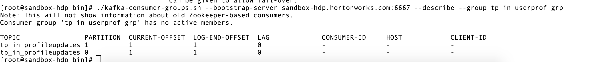

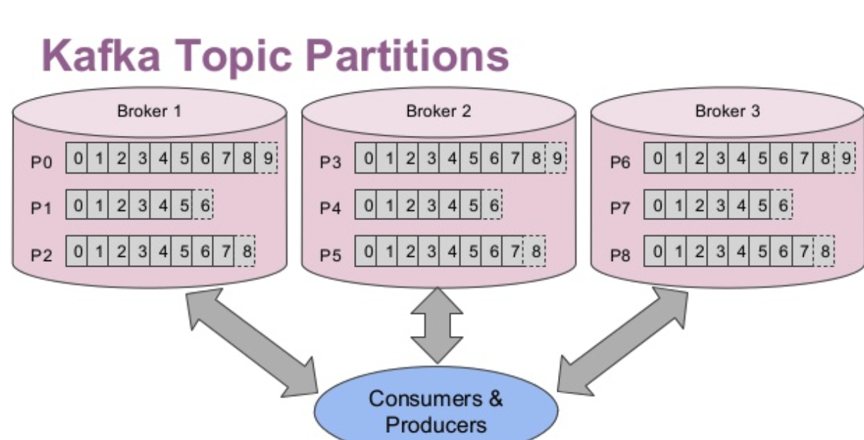

## Spark

### Overview:

A high-performance large-scale data processing analytical engine that supports both batch and streaming data. It uses DAG schedulers, query optimizers and physical execution engines to achieve this performance.

It supports running on Hadoop, Kubernetes, Standalone and Cloud.

### Stack:

### Input:

### spark.sql.Row object

Row[0]

Columns: item_name, item_desc, is_active, created_date

Row[1]

Columns: item_name, item_desc, is_active, created_date

Map Function:

Row_In 🡪 Map Function 🡪 Row_Out

FlatMap Function

Row_In 🡪 Flat Map Function 🡪 [Row_Out, …]

Row_In (item_name, item_desc, is_active, created_date) 🡪 Flat Map Function 🡪 [item_name, item_desc, is_active, created_date]

This converted Single Row with 4 Columns as 4 Rows with Single Column. This is not correct.

Row_In (item_name, item_desc, is_active, created_date) 🡪 Flat Map Function 🡪 [Row_Out (Item1, MyItemDesc, Active/InActive, 2020-11-01), …]

Since we cannot create spark.sql.Row, we should create a POJO and set all required values in it and add to Iterator.

FlatMap

|  |  |
| --- | --- |
| **Input** | **Output** |
| org.apache.spark.sql.Row (Item1, MyDesc, 1, 2020-11-01T01:01:01 | com.css.java.bean.Items(Item1, MyDesc, Active, 2020-11-01)  com.css.java.bean.Items(Item1, MyDesc, Active, 2020-11-01)  com.css.java.bean.Items(Item1, MyDesc, Active, 2020-11-01)  … |

Map

|  |  |
| --- | --- |
| **Input** | **Output** |
| org.apache.spark.sql.Row (Item1, MyDesc, 1, 2020-11-01T01:01:01 | com.css.java.bean.Items(Item1, MyDesc, Active, 2020-11-01) |

### Concepts:

* Submit Job:
  + Deploy-Mode: cluster, client
  + Master: Spark, Local, Yarn, Mesos, Kubernetes(k8)
* Driver
  + Acts as a client to the cluster.
* Executors
  + This is where actual tasks are executed. Code inside Action calls, Map, FlatMap, Filter excutes.
* Spark Context:
  + One per JVM. Represents connection to Spark Cluster and should be used to create RDD/Datasets and cache variables.
* Sources: Files, Streaming Systems, Storage Systems
  + File: textFile, wholeTextFiles, kafka, jdbc(rdbma), ..
* Datasets
  + Distributed collection of data.
* DataFrame:
  + Dataset organized into named columns. Dataset of rows.
  + Equivalent to a table in RDBMS.
* RDD
  + Resilient Distributed Dataset, a fault-tolerant collection of elements that can be operated in parallel.
  + Function: parallelize
  + Operations: Transformations (map), Actions (reduce)
* Functions/Transformations: Map, Flatmap, Filter
  + Map: one-to-one
  + Flatmap: One-to-Many
* Cache: Broadcast, Accumulators
  + By default, each transformed RDD may be recomputed each time you run an action on it.
  + you may also persist an RDD in memory using the persist (or cache) method, in which case Spark will keep the elements around on the cluster for much faster access the next time you query it
  + Save RDD on disk or in-memory.
* Sinks: Files, Streaming Systems, Storages
* Lazy Execution Model:
  + Map executes its functions only when the result of it is written somewhere.
  + The transformations are only computed when an action requires a result to be returned to the driver program
* Closures
* Shuffle: redistributes the data so that it is grouped again differently. Expensive operation. Use at caution. Spark must read from all partitions to find all the values for all keys, and then bring together values across partitions to compute the final result for each key.
  + Repartition, coalesce, groupByKey, reduceByKey, join, cogroup.
  + @TODO difference between Repartition and Coalesce.
    - Repartition: number can be increased or decreased. It makes new partitions and spread data over them evenly. It’s a full shuffle operation.
      * Pros: Equal sized data on each partition.
    - Coalesce: can only be decreased and optimized to use this instead of repartition. This uses existing partitions and moves only chosen partitions.
* Actions: foreach, reduce, count, take, saveAs,
* Spark-SQL
  + SQL API or Dataframe API
  + Read from Hive tables.
* User Defined Functions (UDF)
  + Refer to example code.
* Spark Streaming
* Structured Streaming:
  + A scalable and fault-tolerant stream processing engine with support for fast, scalable, fault-tolerant, end-to-end exactly-once.
  + Atleast Once: refer to examples shared
  + Exactly-Once:
  + Micro-Batch (100 millis) and Continuous (1 milli)
* Window Operations
  + Allows transformations over a sliding window of data.
* Checkpoint
  + Metadata Checkpoint: Config, DStream Operations, Incomplete Batches (queue and not yet completed)
  + Data Checkpoint: Save generated RDDs to reliable storages (Stateful transformations: updateStateByKey, reduceByKeyAndWindow).

### Cluster Mode:

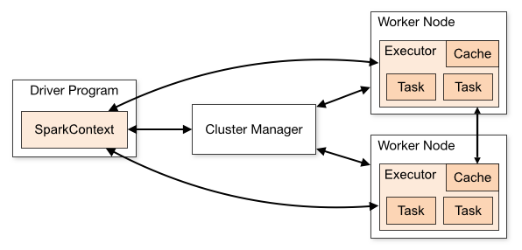

* Driver program create SparkContext.
* Sends application code to the executors
* SparkContext send tasks to the executors to run
* Isolates one application from another sharing the same set of executors. When application is created, context, it gets a set of executor processes. It stays for length of the execution and runs tasks in multiple threads.
* Driver program controls schedule of tasks on the cluster. It should coexist with the worker for better efficiency.

### YARN:

* Acts as resource allocator and Cluster Manager.
* Alternatives: Kubernetes, Apache Mesos.
* YARN-Cluster: Spark driver runs inside an application master process which is managed by yarn on the cluster. Client is released once app is initialized.
* YARN-Client: Drives runs in the client process and the application master is only used for requesting resources from yarn.
* YARN UI: For application monitoring and debugging performance issues:

<https://databricks.com/blog/2015/07/08/new-visualizations-for-understanding-apache-spark-streaming-applications.html>

### Driver:

* Runs main programs
* Creates various parallel operations to perform on executors
* All aggregations runs on driver nodes like: collect(), take()

### Executors:

* All Parallel executions happens on executors
* Execution unit inside each function runs here.

### Sources:

* spark.read.load("...")
  + spark.read.format("json").load("..") //json, parquet, jdbc, orc, libsvm, csv, text
* spark.readStream.format("..”).load()
  + spark.readStream.format("kafka").option("kafka.bootstrap.servers", "host1:port1").option("subscribe", "topic1").load()

### Sink:

* DF.write.format("orc").option(..).save("..")
* DF.write.partitionBy("column_name").format("parquet").save("..")
* DF.writeStream.format("..").start()
  + DF.writeStream.format("kafka").option("kafka.bootstrap.servers", "host1:port1").option("topic", "topic2").start()

### Streaming:

An extension that supports scalable, high-throughput, fault-tolerant stream processing engine.

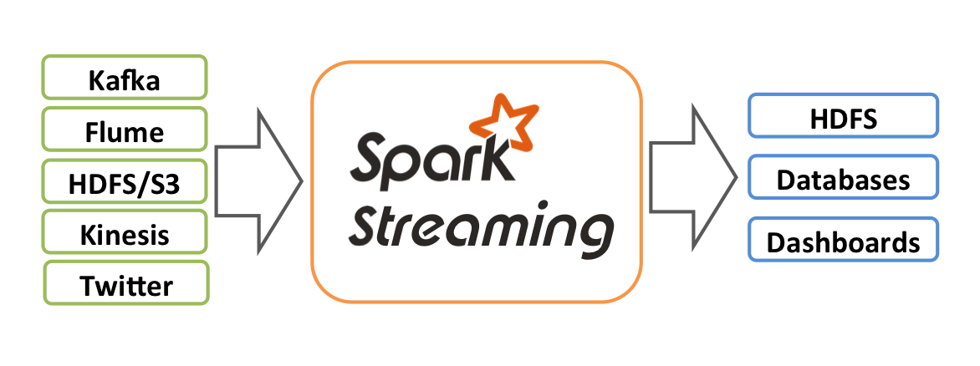

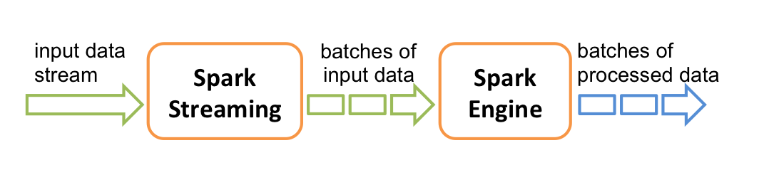

#### DStream:

Discrete Streams, a continuous stream of data. Also referred as sequence of RDDs.

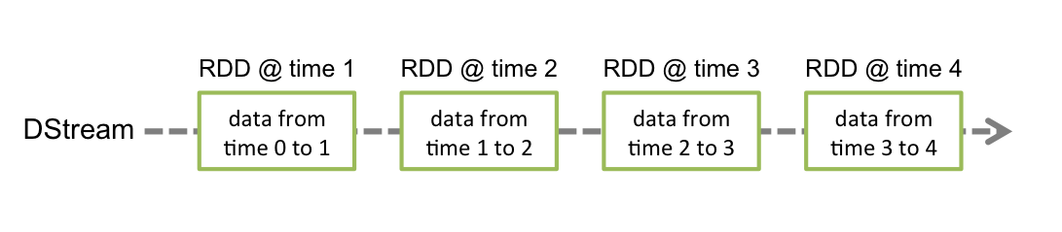

Input DStreams are DStreams representing the stream of input data received from streaming sources like Kafka.

Each RDD in a DStream contains data from a certain interval

Any operation applied on a DStream translates to operations on the underlying RDDs, like split etc.

Each RDD pushed into the queue will be treated as a batch of data in the DStream, and processed like a stream.

Input Sources 🡪 DStream 🡪 Receiver 🡪 Spark In-Memory

#### Window Operations:

Every time the window slides over a source DStream, the source RDDs that fall within the window are combined and operated upon to produce the RDDs of the windowed DStream

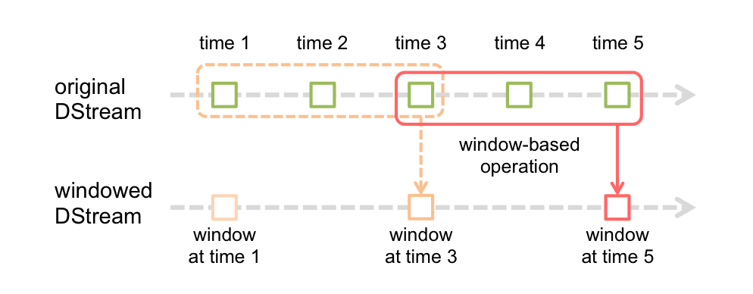

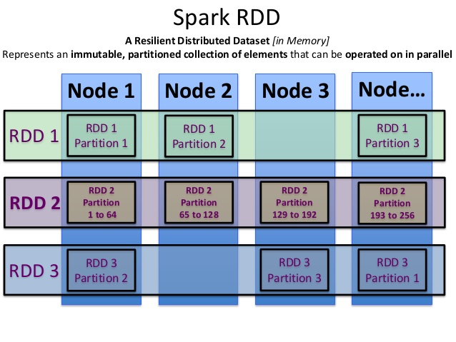

### Spark + Kafka

Provides simple parallelism, 1:1 correspondence between Kafka partitions and Spark partitions, and access to offsets and metadata.

LocationStrategies.PreferConsistent: will distribute partitions evenly across available executors

PreferFixed: allows you to specify an explicit mapping of partitions to hosts

Direct Streaming:

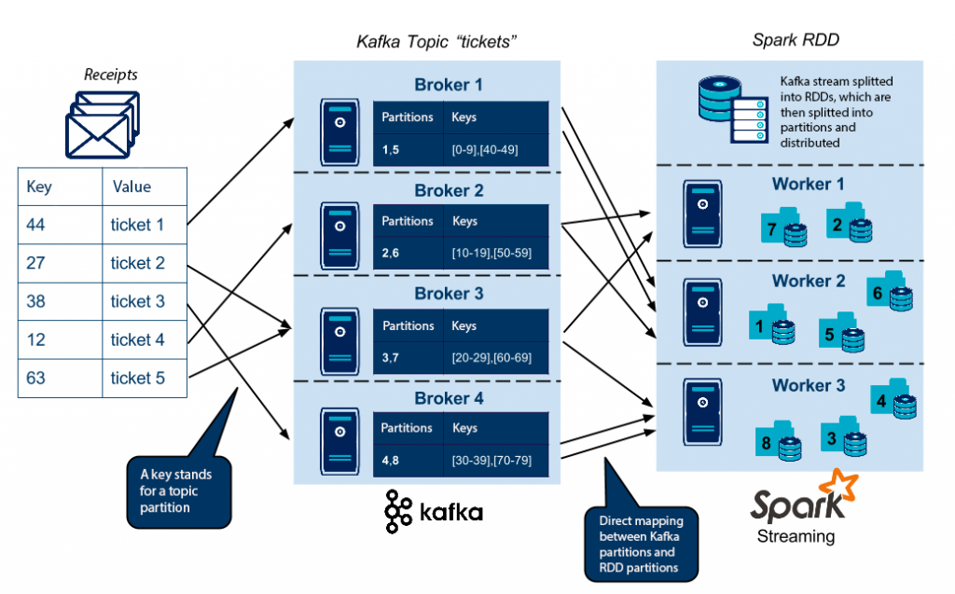

#### RDD (Resilient Distributed Dataset)

An RDD is a fault-tolerant collection of elements that can be operated on in parallel. You can create them parallelizing an existing collection in your driver program, or referencing a dataset in an external storage system, such as a shared filesystem, HDFS, HBase, or any data source offering a Hadoop InputFormat.

#### Stateful:

Spark streaming supports stateful exactly-once out of box.

#### Exactly-Once:

* *At most once*: Each record will be either processed once or not processed at all.
* *At least once*: Each record will be processed one or more times. This is stronger than *at-most once* as it ensure that no data will be lost. But there may be duplicates.
* *Exactly once*: Each record will be processed exactly once - no data will be lost and no data will be processed multiple times. This is obviously the strongest guarantee of the three.

#### Spark-SQL:

Useful for querying structured data using DataFrame API or SQL syntax. Supports filtering, joins, grouping and more. Support HiveQL syntax, UDF’s and direct access to hive data stores.

Uses internally Cost Based Optimization for executing queries. It uses columnar storage and code generation that assist in running performant queries. It will launch spark jobs and use the power of cluster and scale to high volume data queries.

## Kerberos:

Part:1 Define JAAS File:

KafkaClient {

com.sun.security.auth.module.Krb5LoginModule required

doNotPrompt=true

useKeyTab=true

storeKey=true

keyTab="grsld.keytab"

renewTicket=true

serviceName="kafka"

principal="sa_grsld@XYZ.GLOBAL";

};

Client {

com.sun.security.auth.module.Krb5LoginModule required

doNotPrompt=true

useKeyTab=true

storeKey=true

keyTab="grsld.keytab"

renewTicket=true

useTicketCache=true

serviceName="zookeeper"

client=true

principal="sa_grsld@XYZ.GLOBAL";

};

Part:2

Unset and Re-Init before spark-submit:

unset KRB5CCNAME

kinit sa_grsld@IHGINT.GLOBAL -kt /etc/grsld.keytab

klist

Include jaas in the spark-submit

--driver-java-options "-Djava.security.auth.login.config=kafka_client_jaas.conf" \

--files "kafka_client_jaas.conf,/etc/grsld.keytab,./subChannelDescription.csv,/etc/spark2/conf/hbase-site.xml" \

--conf "spark.executor.extraJavaOptions=-Djava.security.auth.login.config=kafka_client_jaas.conf" \

## Broadcast:

Setting Broadcast:

//query an existing hive table and save data in to broadcast

Dataset<Row> dtoLookUpDF = _sparkSession.sql(kafkaConfig.getDtoLookUpQuery());

List<Row> rows = dtoLookUpDF.collectAsList(); //fetch all data in to a list

//create a broadcast variable and save in to it.

Broadcast<List> lookUpBroadcastVar = _sparkSession.sparkContext().broadcast(rows,

scala.reflect.ClassManifestFactory.fromClass(List.class));

brdCstTblRefs.put("LOOKUP-QUERY", lookUpBroadcastVar);

//Accessing the save broadcast var:

Pass this: Broadcast<List> lookUpBroadcastVar to the methods

if (broadcastMap != null && broadcastMap.get("LOOKUP-QUERY") != null)

hotelBrandDFRows = broadcastMap.get("LOOKUP-QUERY").value();

## HBase:

A highly scalable, distributed big data storage system. It is a column-oriented non-relational database modeled after Google’s Bigtable. It runs on HDFS. Fault-tolerant ways to store sparse datasets.

Supports random realtime read/write access to Big Data.

Cons:

* Lack of supports for sql syntax.
* Data cannot be written in AVRO etc formats.
* Every record access must happen using primary-key.

### Features:

* Linear and modular scalability.
* Strictly consistent reads and writes.
* Automatic and configurable sharding of tables
* Automatic failover support between RegionServers.
* Block cache and Bloom Filters for real-time queries.
* Query predicate push down via server side Filters

HBase allows for many attributes to be grouped together into column families, such that the elements of a column family are all stored together. This is different from a row-oriented relational database, where all the columns of a given row are stored together. With HBase you must predefine the table schema and specify the column families. However, new columns can be added to families at any time, making the schema flexible and able to adapt to changing application requirements.

Command Line:

@instance-1 spark]$ hbase shell

hbase(main):001:0> list

TABLE

log_agg

1 row(s)

Took 0.5507 seconds

=> ["log_agg"]

hbase(main):002:0> scan 'log_agg'

ROW COLUMN+CELL

\x00\x00\x00\x00\x00\x00\x00\x00 column=cf:application, timestamp=1585964037762, value=XYZ

\x00\x00\x00\x00\x00\x00\x00\x00 column=cf:message, timestamp=1585964037762, value=Message-1

\x00\x00\x00\x00\x00\x00\x00\x00 column=cf:module, timestamp=1585964037762, value=ModuleX

\x00\x00\x00\x00\x00\x00\x00\x01 column=cf:application, timestamp=1585964037762,

## Hive:

Apache Hive is an open source data warehouse software for reading, writing and managing large data set files that are stored directly in either the [Apache Hadoop Distributed File System (HDFS)](https://www.ibm.com/analytics/hadoop/hdfs) or other data storage systems such as [Apache HBase](https://www.ibm.com/analytics/hadoop/hbase). Hive enables SQL developers to write Hive Query Language (HQL) statements that are similar to standard SQL statements for data query and analysis.

Hive metastore, which enables you to apply a table structure onto large amounts of unstructured data.

Once you create a Hive table, defining the columns, rows, data types, etc., all of this information is stored in the metastore

Hive looks like traditional database code with SQL access. However, Hive is based on Apache Hadoop and Hive operations, resulting in key differences

First, Hadoop is intended for long sequential scans and, because Hive is based on Hadoop, queries have a very high latency (many minutes). This means Hive is less appropriate for applications that need very fast response times.

Second, Hive is read-based and therefore not appropriate for transaction processing that typically involves a high percentage of write operations. It is better suited for data warehousing tasks such as extract/transform/load (ETL), reporting and data analysis and includes tools that enable easy access to data via SQL.

## Data Formats:

### AVRO

Avro, as a component, supports a rich set of primitive data types including: numeric, binary data and strings; and a number of complex types including arrays, maps, enumerations and records. A sort order can also be defined for the data.

### ORC:

### PARQUET:

# Scala Program:

# Build and Deploy:

## Project:

### IDE:

IntelliJ

### Project:

New -> Project from Existing Source

Select the folder where you have unzipped the Spark.zip file

Or

New -> Project -> Scala -> sbt

## Build:

This is based on “sbt”. Please refer to “sbt” documentation for more information.

<https://www.scala-sbt.org/1.x/docs/sbt-by-example.html>

### Compile & Package:

>sbt clean compile package

## Payload:

>cd <source-dir>

>ls -lh target/scala-2.11/

Check for “spark-streaming_2.11-0.1.jar”

## Upload:

#### To Sandbox:

Local to Sandbox:

> scp target/scala-2.11/spark-streaming_2.11-0.1.jar [root@192.168.5.137:/tmp](mailto:root@192.168.5.137:/tmp)

Sandbox to Final-Cluster:

>scp root@192.168.5.137:/tmp/spark-streaming_2.11-0.1.jar /opt/training/spark/

#### To GCP:

1: Gcp-cloud-console: <https://console.cloud.google.com/>

2: 

3: Upload File:

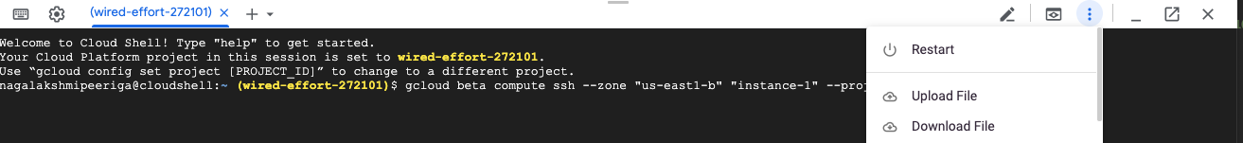

4: Select the payload jar file “spark-streaming_2.11-0.1.jar” and upload it.

5: Upload to final Hadoop-cluster-node:

>gcloud beta compute scp --project="wired-effort-272101" --zone="us-east1-b" --recurse ./spark-streaming_2.11-0.1.jar "instance-1":~/

>gcloud beta compute scp --project="wired-effort-272101" --zone="us-east1-b" --recurse ./runcmd.sh.* "instance-1":~/

>gcloud beta compute scp --project="wired-effort-272101" --zone="us-east1-b" --recurse ./config.properties "instance-1":~/

6: Login to the hadoop-cluster-node:

> gcloud beta compute ssh --zone "us-east1-b" "instance-1" --project "wired-effort-272101"

## Run Program:

### Sandbox:

> cd /opt/training/spark

> sh runcmd.sh.produce

> sh runcmd.sh.consume (new shell window)

### GCP:

> gcloud beta compute ssh --zone "us-east1-b" "instance-1" --project "wired-effort-272101"

> cd /opt/training/spark

> vi config.properties (edit this file and change the properties like bootstrap.servers, topic.name etc)

> sh runcmd.sh.produce

> sh runcmd.sh.consume (new shell window)

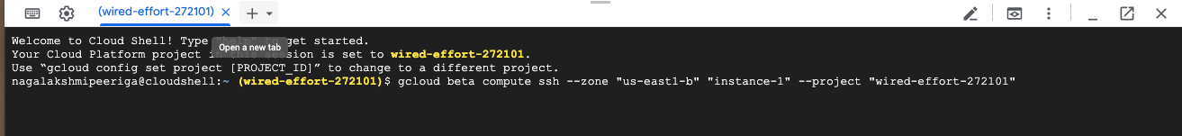

# Applications

## Produce Data to Kafka

Program: DataProducer.scala

Partition Param: Code that support partition key hash.

References: <http://kafka.apache.org/documentation.html#producerapi>

## Consume Data from Kafka

Program: DataConsumer.scala

References: <http://kafka.apache.org/documentation.html#consumerapi>

## Kafka Streams Application

Program: KafkaStreaming.scala

References: <http://kafka.apache.org/documentation.html#streamsapi>

Configuration:

<http://kafka.apache.org/documentation.html#configuration>

## Spark Application:

### Read from Kafka:

com.cirrus.training.SparkStreaming

Submit File: runcmd.sh.spark (change config.properties and runcmd.sh.spark as needed)

### Apply Transformation

### Write to HDFS

### Write to HIVE

### Write to HBase

# Troubleshoot:

1:

Brokers:

>cd /usr/hdp/3.0.1.0-187/zookeeper/bin

>./zkCli.sh -server localhost:2181

[zk: localhost:2181(CONNECTED) 8] get /brokers/ids/1001

{"listener_security_protocol_map":{"PLAINTEXT":"PLAINTEXT"},"endpoints":["PLAINTEXT://sandbox-hdp.hortonworks.com:6667"],"jmx_port":-1,"host":

"sandbox-hdp.hortonworks.com","timestamp":"1584900008505","port":6667,"version":4}

2:

Caused by: java.lang.ClassNotFoundException: scala.Predef$

at java.net.URLClassLoader.findClass(URLClassLoader.java:382)

Solution: Make sure scala-lang library is picked properly in the classpath.

Ex: /usr/hdp/3.0.1.0-187/kafka/libs/scala-library-2.11.12.jar

3: Ambari Related Actions:

[root@sandbox-hdp ~]# ambari

ambari-admin-password-reset ambari-python-wrap ambari_server_main.py ambari-thp-disable.sh

ambari-agent ambari-server ambari-server.py

4: Zookeeper Related Actions:

[root@sandbox-hdp ~]# zookeeper-

zookeeper-client zookeeper-server zookeeper-server-cleanup

# Interview Preparation:

|  |  |
| --- | --- |
| Application | User program built on Spark. Consists of a driver program and executors on the cluster. |
| Application jar | A jar containing the user's Spark application. In some cases users will want to create an  "uber jar" containing their application along with its dependencies. The user's jar should never  include Hadoop or Spark libraries, however, these will be added at runtime. |
| Driver program | The process running the main() function of the application and creating the SparkContext |
| Cluster manager | An external service for acquiring resources on the cluster (e.g. standalone manager, Mesos,  YARN) |
| Deploy mode | Distinguishes where the driver process runs. In "cluster" mode, the framework launches the  driver inside of the cluster. In "client" mode, the submitter launches the driver outside of the  cluster. |
| Worker node | Any node that can run application code in the cluster |
| Executor | A process launched for an application on a worker node, that runs tasks and keeps data in  memory or disk storage across them. Each application has its own executors. |
| Task | A unit of work that will be sent to one executor |
| Job | A parallel computation consisting of multiple tasks that gets spawned in response to a Spark  action (e.g. save, collect); you'll see this term used in the driver's logs. |
| Stage | Each job gets divided into smaller sets of tasks called stages that depend on each other  (similar to the map and reduce stages in MapReduce); you'll see this term used in the  driver's logs. |